Code Project and Documentation
HW1 ECEN 602 FALL 2012

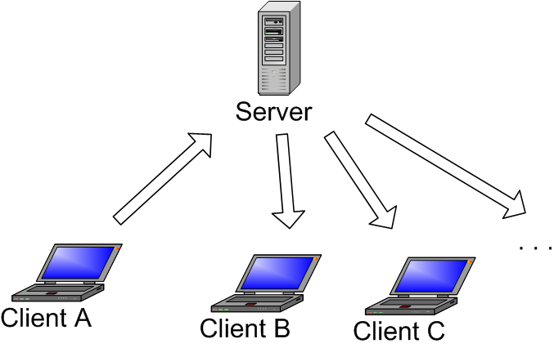

The Simple Broadcast Chat Protocol (SBCP) is a protocol that allows clients to
join and leave a global chat session, view members of the session, and send and
receive messages. An instance of the server provides a single “chat room”, which
can only handle a finite number of clients. Clients must explicitly JOIN the
session. A client will receive a list of the connected members of the chat session
once they complete the JOIN transaction. Clients will use SEND messages to
carry chat text, and will receive chat text from the server using the FWD
message. Clients may exit unceremoniously at any time during the chat session.
The server should detect this, cleanup the resources allocated to that client and

notify the other clients. Additionally, the client program will be able to detect idle
clients and notify the server.

This project has 3 files:
client.c,server.c and SBCPHeader.h. Entire coding of project is done using C with Socket programming system calls.

for running server we have to provide 3 arguments, IP address on which have to run,port to open for accepting socket and maximum number of clients that can be attached to it.

For running client, 3 arguments: username of client entering,server IP address and Port number to which client connects at server.

We have divided the client code and server code into each file and both are accessing the same header file SBCPHeader.h

SBCPHeader.h: this file declares the format of packets to be send between client and server so that there should be uniformity of packets send.

SERVER FILE

It opens its socket for connection after binding its IP to socket and waits for select for any incoming connection. When anyclient connects to it, it checks` it header format,maximum number of client and if both saisfies , it sends the ACK msg with number of clients in network along with username.if version,max number of client exceed, and username already exceed then it should send NAK msg.

USername list is defined as a structure in which name,pid and status are fields.This list is keeps on updated by a server, if any client joins,goes offline or becomes idle.This is a linked list and general operations of search,add,delete are written using linked list in the server code. Once its send ack msg to connecting client it sends the other clients in its network about this new client and sends them online message.if any clients goes offline or gets idle for 10 sec it sends all other client about this information.

CLIENT FILE

this file connects it to the server with the port supplied by server while executing with username to be entered.Client first sends the join msg to server to connect and server in returns the online client list to user.Client can also receive any chat from any other client via server.It will go to idle state after 10 sec if user doesnt enter soemthing on idle and will woke up only when user enters something from terminal.this idle message is send to server which server in turns send to all other clients.For all the clients in the list, servers sends online,offline and idle msg activity to all clients.
Each file has basically two functions:

HEADER FILE

this file has the basic structure of SBCP header message and attribute.SBCP Msg has vrsn type and full message length while SBCP header has attribute type and length of attribute.

MakePacket and ExtractPacket.

MakePacket:
this function takes all the necessary arguments and prepares a packet in a proper format to send it over to network.

ExtractPacket:
this function takes packet receive from other side and extracts it into type of packet,attribute type and payload information.

BASIC ARCHTIECTURE:

Receive from client---->Make Packet-----> Send Packet-----> Receive Packet------>Extract Packet------>Send it to Client

How to Complile:

1.makefile server: compiles the server and creates executable server.o
2.makefile client: compiles the client and creates executable client.o

How to Run:

1./server <IP address> <Port> <maximum number of client>
2./client <username> <IP address> <Port>

References:
Beej Guides: great help from this.
Class presentation.
Stackoverflow.com
piazza forum and Friends

TEAM: # 1

1.ANKIT GUPTA
UIN: 621009649
ankitgupta@tamu.edu

2.OSAMA ARSHAD
UIN:315004499

